Comparative User Experience Study and Interface Design for Gmail and Microsoft Outlook

1. Aim
To study the user experience of Gmail and Microsoft Outlook, identify common problems faced by users while managing emails, and design an improved email interface using the Design Thinking approach involving Empathize, Define, Ideate, Prototype, and Test.

2. Problem Description
Email has become an essential communication tool for students, faculty members, and professionals. Gmail and Outlook provide several features such as sending and receiving emails, organizing messages, searching emails, attaching files, and managing contacts.
However, users may face difficulties such as:
- Finding important emails among a large number of messages.
- Managing unwanted or promotional emails.
- Locating attachments quickly.
- Organizing emails using labels, folders, or categories.
- Identifying urgent messages.
- Understanding some interface options and icons.
- Managing multiple email accounts.
- Switching between email, calendar, and other services.
Therefore, this practicum focuses on understanding user difficulties in Gmail and Outlook and proposing an improved email interface that makes email organization, searching, and communication easier and more efficient.

3. Target Users
The proposed system mainly targets:
Target User | Requirements
College Students | Easy email management, assignment attachments, quick search
Faculty Members | Managing student communication and important documents
Office Staff | Organizing professional emails and attachments
Working Professionals | Managing large volumes of emails and meetings
New Email Users | Simple and understandable interface

4. Empathize
The Empathize stage focuses on understanding the actual problems, needs, and expectations of email users.
4.1 Interview / Survey Questions
A short survey was prepared for email users.
- Which email service do you use regularly?
- How frequently do you check your email?
- Do you find it difficult to locate an old email?
- Do you find it difficult to identify important emails?
- How do you organize your emails?
- Do you face problems while finding attachments?
- Do you receive too many promotional or unwanted emails?
- Which feature of Gmail or Outlook do you find difficult to use?
- Do you prefer folders, labels, or categories for organizing emails?
- What improvement would you like to see in an email application?

4.2 User Responses
A sample survey was conducted with 5 users.

Question/Issue | User Response
Difficulty finding old emails | 4 out of 5 users
Too many promotional emails | 4 out of 5 users
Difficulty finding attachments | 3 out of 5 users
Difficulty identifying important emails | 3 out of 5 users
Difficulty organizing emails | 3 out of 5 users
Need for a simpler interface | 4 out of 5 users
Need for better search | 4 out of 5 users

4.3 Persona
Persona: College Student
Name:Ananya
Age:20
Occupation: College Student
Goals:
- Quickly find college-related emails.
- Download assignments and documents easily.
- Identify important messages.
- Avoid missing messages from faculty.
Pain Points:
- Large number of emails.
- Difficulty finding old messages.
- Promotional emails mixed with important emails.
- Attachments are sometimes difficult to locate.
Needs:
- Simple dashboard.
- Smart search.
- Important email section.
- Easy attachment filtering.
- Clear categories.
Persona Summary
"I want to find important college emails and attachments quickly without going through hundreds of messages."

5. Define
5.1 Problem Statement
College students and faculty members need a simple and efficient email interface because managing large numbers of emails, finding important messages, and locating attachments can be time-consuming and confusing.
How Might We?
How might we design a simple email interface that helps users quickly find, organize, and manage important emails and attachments?

6. Ideate
During the Ideate stage, different possible solutions were considered.
6.1 Possible Solutions
Solution 1 – Smart Email Categorization
Automatically organize emails into categories such as:
- Academic
- Personal
- Work
- Promotional
- Important
Solution 2 – Advanced Search
Provide simple filters such as:
- Sender
- Date
- Subject
- Attachment
- Unread
- Important
Solution 3 – Attachment Center
Create a separate section where users can view all email attachments in one place.
Solution 4 – Priority Inbox
Display important emails at the top and less important emails below them.
Solution 5 – Unified Dashboard
Combine email, calendar, tasks, and contacts into an easy-to-understand dashboard.

6.2 Selected Solution
Smart Email Management Dashboard
The selected solution combines the most useful ideas into one interface.
The proposed interface includes:
- Smart email categories.
- Advanced search.
- Priority/Important Inbox.
- Attachment Center.
- Calendar and task access.
- Simple navigation.
This solution was selected because it directly addresses the major problems identified during the Empathize stage.

7. Test
The prototype was tested with 3 users representing the target audience.
User 1 – Student
Feedback:
- Dashboard is easy to understand.
- Attachment Center is useful.
- Requested a clearer notification indicator.
User 2 – Faculty Member
Feedback:
- Smart categories are useful.
- Search filters make finding emails easier.
- Suggested adding a calendar shortcut.
User 3 – Student
Feedback:
- Important email section is helpful.
- Interface is less confusing.
- Suggested adding a dark mode option.

Testing Summary
Feature | User Feedback
Simple Dashboard | Positive
Smart Categories | Positive
Advanced Search | Highly useful
Attachment Center | Highly useful
Important Inbox | Positive
Calendar Shortcut | Suggested
Dark Mode | Suggested

8. Improvements
Based on the testing results, the following improvements were identified:
1. Improved Notifications
A clearer notification indicator can help users identify new and urgent emails.
2. Calendar Integration
A calendar shortcut can help students and faculty manage meetings and academic events.
3. Dark Mode
A dark-mode option can provide an alternative viewing experience.
4. Better Attachment Search
Users should be able to search attachments by file name, type, sender, and date.

5. Priority Identification
Important emails can be visually highlighted so that users do not miss urgent messages.
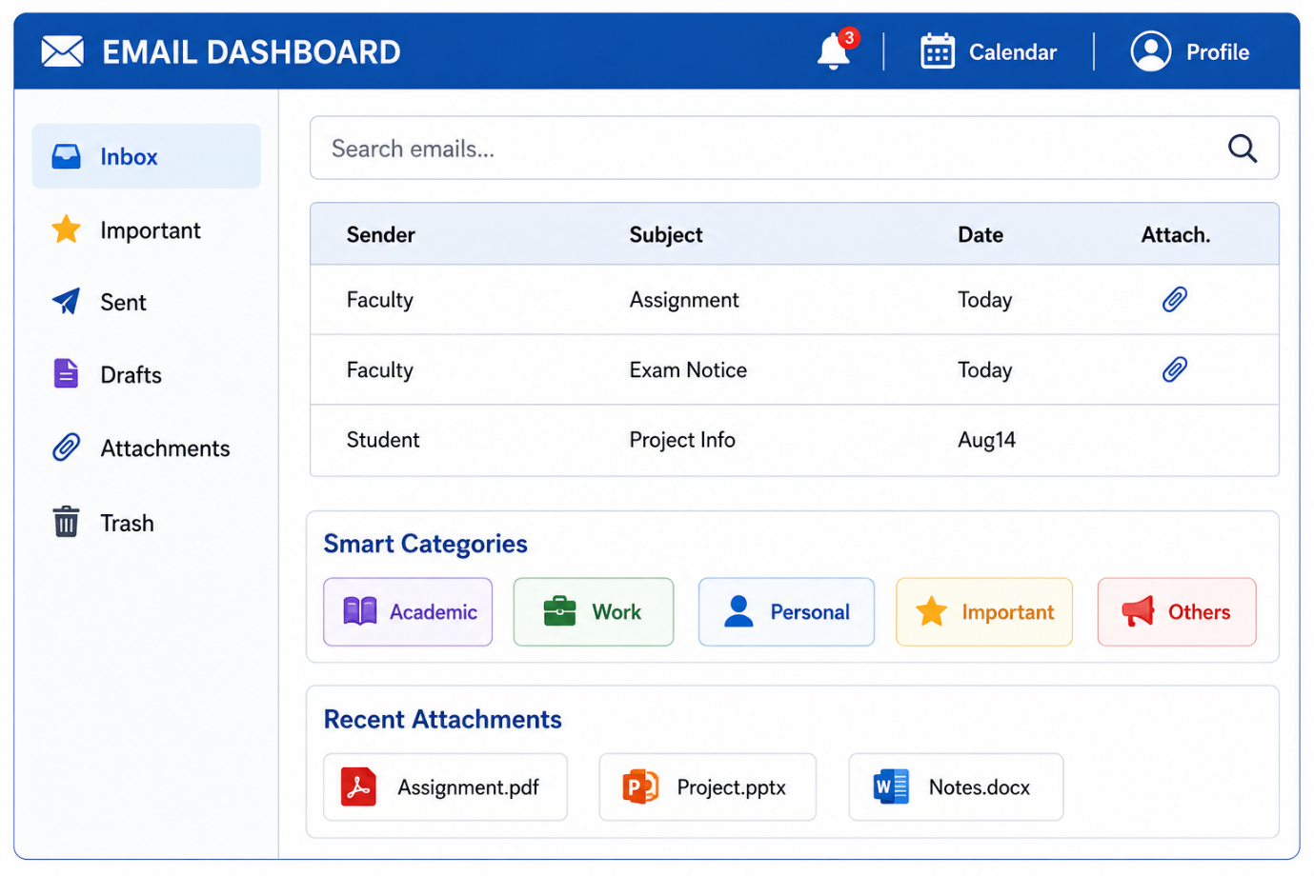

9. Final UI Sketch
The final design combines the tested improvements.
10. Result
The practicum successfully applied the Design Thinking methodology to study and improve the user experience of Gmail and Outlook.
The Empathize stage identified major user difficulties in email management. The Define stage converted these difficulties into a clear problem statement. During the Ideate stage, multiple solutions were considered and a Smart Email Management Dashboard was selected.
A prototype consisting of six major UI screens was developed and tested with users. Based on their feedback, improvements such as better notifications, calendar integration, dark mode, and improved attachment search were identified.

